1.(a)

>setwd("C:/Users/chuanju/Documents/2016_MSBA UTD/2016 Fall Classes/ECON 6306_Applied Econometrics/Problems/Problem 1")

> star = read.csv("star.csv")

> small_total = subset(star, small==1|regular==1, c("small","totalscore"))

> plot(small_total)

> lm(totalscore~small, small_total)

Call:

lm(formula = totalscore ~ small, data = small_total)

Coefficients:

(Intercept) small

918.0 13.9

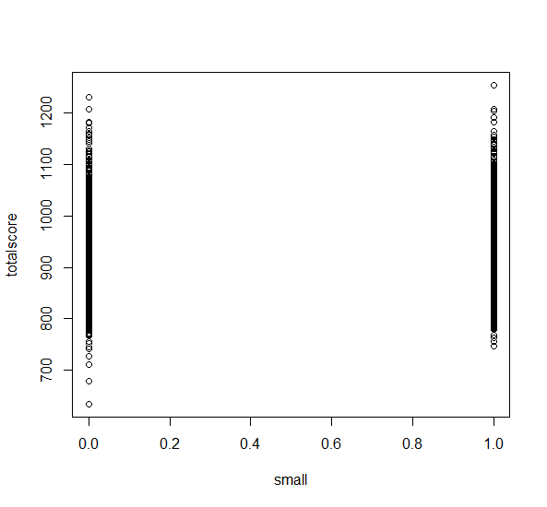

Interpretation : The expected TOTALSCORE of a small-sized class student is 13.9 higher than that of a regular-sized class student. (931.9 v. 918.0 )

(b)

> small_read = subset(star, small==1|regular==1, c("small","readscore"))

> lm(readscore~small,small_read)

Call:

lm(formula = readscore ~ small, data = small_read)

Coefficients:

(Intercept) small

434.733 5.819

Interpretation : The expected READSCORE of a regular-sized class student is 434.733 while the expected READSCORE of a small-sized class student is 434.733+5.819 = 440.552.

> small_math = subset(star, small==1|regular==1, c("small", "mathscore"))

> lm(mathscore~small, small_math)

Call:

lm(formula = mathscore ~ small, data = small_math)

Coefficients:

(Intercept) small

483.31 8.08

Interpretation : The expected MATHSCORE of a regular-sized class student is 483.31 while the expected MATHSCORE of a small-sized class student is 483.31+8.08 = 491.39

(C)

> aide_total = subset(star, regular==1|aide==1, c("aide", "totalscore"))

> lm(totalscore~aide,aide_total)

Call:

lm(formula = totalscore ~ aide, data = aide_total)

Coefficients:

(Intercept) aide

918.0429 0.3139

Interpretation : It indicates there is no much difference between the expected TOTALSCOREs of a regular-sized student without aide and a regular-sized student with aide. (918.04 v. 918.36)

(d)

> aide_math = subset(star, regular==1|aide==1, c("aide","mathscore"))

> str(aide_math)

'data.frame': 4048 obs. of 2 variables:

$ aide : int 1 1 0 1 1 0 1 1 0 1 ...

$ mathscore: int 478 494 513 468 449 536 484 626 454 439 ...

> lm(mathscore~aide, aide_math)

Call:

lm(formula = mathscore ~ aide, data = aide_math)

Coefficients:

(Intercept) aide

483.3102 -0.3915

Interpretation : It indicates there is no much difference between expected MATHSCOREs of a regular-sized student without aide and a regular-sized student with aide. (483.3102 v. 482.9187)

> aide_read= subset(star, aide==1|regular==1,c("aide","readscore"))

> lm(readscore~aide,aide_read)

Call:

lm(formula = readscore ~ aide, data = aide_read)

Coefficients:

(Intercept) aide

434.7327 0.7054

Interpretation : It indicates there is no much difference between expected READSCOREs of a regular-sized student without aide and a regular-sized student with aide. (434.7327 v. 435.4381)

 

(a)

Sum of squared least squares residuals /49 = 2.04672,

So, the sum of squared least squares residuals = 49*2.04672 = 100.2893

(b)

Var(b2) =0.00098, then standard error se(b2) = sqrt(0.00098) =0.0313

Var(b2) = (Xi – Xbar)2 = 0.00098, so (Xi – Xbar)2 = 2.04672/0.00098 = 2088.49

( c)

b2 = 0.18 means when males 18 years or older who are high school graduate increasing 1 percentage, the state’s mean income increases by 0.18 thousand = $180

(d)

b1= ybar – b2 * xbar = 15.187 - 0.18 * 69.139 = 2.74198

(e)

(Xi – Xbar)2  = Xi2 - Xbar2 = 2088.49, 　 Xi2 = 2088.49 + Xbar2 = 2088.49 + 69.1392 = 6868.69

(f)

Yi = 12.274,

Yi hat = b1+b2*Xi = 2.74198 + 0.18*58.3 = 13.23598

Lease squares residual = Yi – Yi hat = 12.274 – 13.23598 = - 0.96198

 

(a)

b2 = 0.076 means when work experience EXPER increases 1 year, RATING increases 0.076

(b)

95% confidence interval of  :

tc = 2.074, (degree of freedom =22).

b2 – 2.074 *se(b2) = 0.076- 2.074*0.044 = -0.015256

b2 + 2.074 *se(b2) = 0.076+ 2.074*0.044 = 0.167256

95% confidence interval = [-0.0152, 0.167]

(c)

H0 :  = 0, H1 :   

    t = b2 – 0) / se(b2) = 0.076/0.044 = 1.727

t(0.975, 22) = 2.074, t(0.025, 22) = -2.074

-2.074 < 1.727 < 2.074 so we can not reject H0 at   = 0.05

(d)

H0 :  = 0, H1 :    

    t = b2 – 0) / se(b2) = 0.076/0.044 = 1.727

t(0.95, 22) = 1.717,

1.727 > 1.717, so we reject H0 and accept H1 :    at   = 0.05. It means there is statistically significant positive relationship between EXPER and RATING

(e)

p-value = 0.0982 >  = 0.05

so we do not reject H0